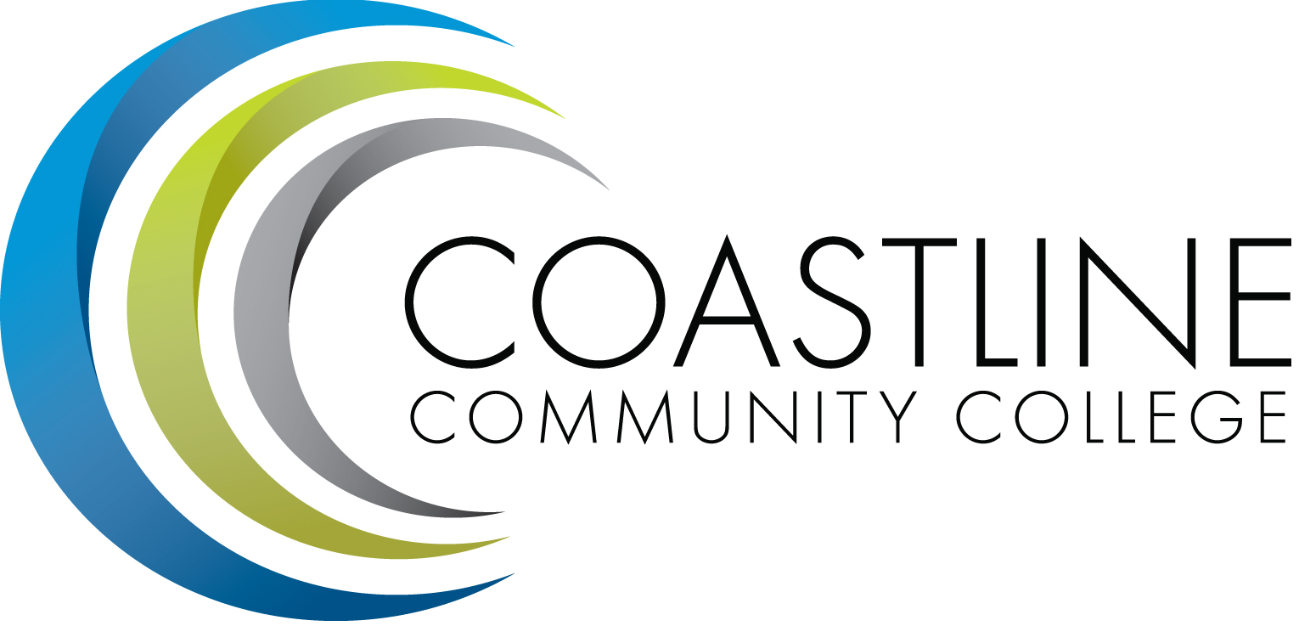

College Professional Development & Leadership Committee Agenda
12/06/2016
3:00 pm to 5:00 pm
College Center, Distance Learning Conference Room

Committee Mandate: To promote, coordinate, recommend, and support the creation and delivery of professional development and leadership programs that increase the effectiveness of our institution and the satisfaction of our employees.
- CALL TO ORDER
  - Roll Call

Present | Members
 | Bob Nash, Co-chair, Associate Dean, Distance Learning & Prof. Development
 | Cheryl Chapman, Co-chair, Academic Senate Representative
 | Mitchell Alves, Faculty Success Center Coordinator
 | Judy Garvey, MECTBD Administrator Representative
 | Elaine Hill, Classified Senate Representative
 | Ken Leighton, Academic Senate Representative
 | Dorothy McCollom, Classified Senate Representative & Committee Support
 | Renate Akins, Director of HR
 | Araba Mensah, Classified Senate Representative
 | Randall Warwick, Academic Senate Representative

  - Welcome
  - Adoption of Agenda
  - Approval of Minutes: 11/01/2016

- SPECIAL REPORTS & UPDATES
  - Demo Cornerstone (Bob Nash/Renate Akins)
  - Kognito Demo (Nate Harrison)

- ACTION ITEMS
  - None

- STANDING REPORTS
  - None

- DISCUSSION ITEMS
  - Creating a New Training Needs Survey for Each Discipline/Department (Aeron)
  - Summer Institute Survey Proposed Topics Vote from Classified (Araba)
  - Input from CMT on Spring workshop topics
  - Input for Academic Senate on Spring workshop topics

- ANNOUNCEMENTS (1-2 minutes per)
  - Coast Canvas Boot Camp, January 23 & 24, 2017 (Bob)
  - Next Meeting, February 7, 2017 at 3:00 pm

- ADJOURNMENT

